Epidemiological calculations
Student’s name
Tutor’s name
date
Question 1.
Refer to the following 2 by 2 table and answer the questions shown:

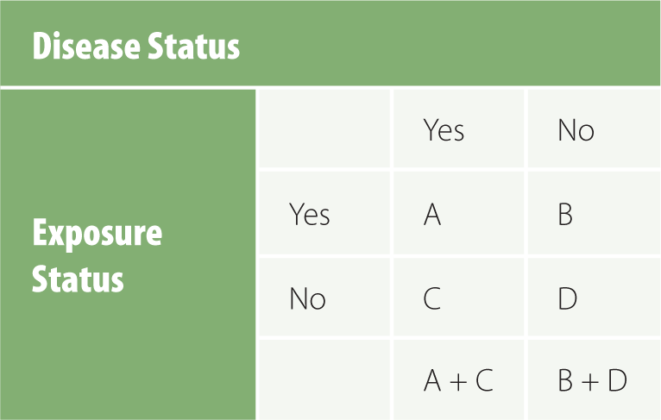
A = 21; B = 9; C = 3; B + D = 11

- A+C= 24
- D=2
- OR= $\frac{A/C}{B/D} =\frac{21/3}{9/2}$ 1.555555556
- Given the results of your calculations and assuming the results are statistically significant, would you say that the exposure is a risk factor or protective factor for the disease?

Answer The exposure is a risk factor because there is a positive relationship between the exposure and risk associated. The more a person is exposed the more the risk of getting the disease

Question 2.
Calculate the OR for the following 2 by 2 table:
Outcome
Yes No
Factor
Yes 37 68
No 24 121
(OR=Odds ratio)
OR= $\frac{37/24}{68/121}$ = $\frac{1.541666667}{0.561983471}$ = 2.743259805

Question 3.
Table X
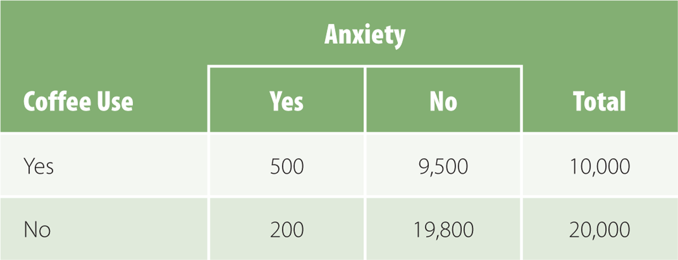
A cohort study was conducted to investigate the association between coffee consumption and anxiety in a population-based sample of adults. The data are presented table X.
- What is the RR of anxiety associated with coffee use?
Relative risk
Risk Ratio = $\frac{500/10000}{200/20000}$ =$\frac{0.05}{0.01}$ = 5times more anxious to the use of coffee
- Calculate the risk (rate) difference.
P for yes= $\frac{500}{10000}$ =0.05
P for no =200/20000 =0.01
Risk difference =0.05-0.01
=0.04×100
4%
- What is the etiologic fraction?
Answer It is the probability that shows the cases where exposure of the population to the risk leads to the individual getting the disease.
- Determine the population etiologic fraction.
=$\frac{0.05-0.01}{0.05}$ =0.04/0.05
=0.8 or 4/5
=80%

